Final Report

FERMENTATION: THE EFFECT OF TEMPERATURE ON CELL GROWTH & XANTHAN PRODUCTION

Kathryn Atherton

Matt Muskat

Alex Smith

Holly Spiritoso

Bioprocess Engineering Laboratory

Agricultural & Biological Engineering

West Lafayette, IN 47906

March 9th, 2018

***Summary***

*Xanthomonas campestris* can be used in fermentation reactions to convert glucose into xanthan gum. This process is used commonly in industry because xanthan gum cannot be synthesized, and xanthan gum is a popular material used as a thickening agent and emulsifier in food products. In order to operate at production efficiency, it is critical to know the temperature dependence of *Xanthomonas campestris* growth and xanthan gum yields from glucose.

In order to determine the temperature dependence of these variables, three pairs of *Xanthomonas campestris* cultures were inoculated at 24 hour intervals, respectively. One culture from each time pair was incubated at 25˚C while the other was incubated at 30˚C and samples of all cultures were collected every 45 minutes after the third culture had been initially inoculated. The samples were centrifuged to separate the supernatant from the cells in order to analyze cell growth, glucose concentration, and xanthan concentration at different temperatures and times. The cell pellets were used to measure relative cell density while the supernatant was used to measure glucose and xanthan concentration Relative cell density was measured using spectrophotometry, and this data was used for qualitative analysis of cell growth. Glucose and xanthan gum concentrations were quantitatively measured using spectrophotometry.

The principle results of this experiment were finding relative cell density and cell growth rate of *Xanthomonas campestris*, xanthan gum concentration, and glucose concentration as functions of temperature and time. These functions were comparatively analyzed at two different temperatures to determine which temperature would yield greater xanthan gum production rates. The results showed that at an incubation temperature of 30˚C, xanthan gum production yields were greater than at an incubation temperature of 25˚C. However, there were conflicting results with cell growth rates compared to final relative cell density. This was likely due to the empirical data being observed to have large error. A possible source of error could be the use of multiple spectrophotometers and the values could have varied between machines. There was fluctuation in the data values on the spectrophotometers which caused error as well.

The results showed that there is a difference in *Xanthomonas campestris* growth and production of xanthan gum between the two fermentation temperatures tested. Although the fermentation at 25˚C had a faster cell growth rate, the 30˚C fermentation resulted in a higher final relative cell density and final xanthan gum concentration. It is recommended that for the most cost-efficient fermentation process, the more ideal temperature of 30˚C is used.

***Introduction***

Fermentation is a chemical process involving the breakdown of sugars by yeast or bacteria. *Xanthomonas campestris* converts glucose into xanthan gum. The useful rheological properties of xanthan gum make it commonly used as a thickening agent, emulsifier, and lubricant in the food industry (Shu & Yang, 1989**)**. Despite its useful nature, it is costly to produce (Shu & Yang, 1989). Due to the process relying on both time and ambient temperature, there is ideally a more cost-effective method to the production. Analysis of the factors that affect fermentation could lead to production improvements in industry. The goal of this experiment was to determine the temperature dependence of xanthan concentration, glucose concentration, and relative cell density. During fermentation, cells typically go through six stages of growth: lag phase, acceleration phase, growth phase, decline phase, stationary phase, and death phase (Doran, 2013). The lag phase, stationary phase, and death phase were not analyzed in this experiment. Three culture pairs were inoculated over three consecutive days which provided the ability to analyze the effect of temperature on xanthan gum production over a larger time period. In this work, the three culture pairs at different times had one culture from each time at 25℃ and 30℃. The absorbance of glucose and xanthan in the solutions were measured to calculate yield and production rate. A colorimetric test was used for measuring the glucose concentration followed by the use of a spectrophotometer. Creation of a calibration curve, use of an oven-drying method, and spectrophotometer were used to determine xanthan concentration. The optical density was measured to determine relative cell density.

***Theory/Basic Principles***

Cell growth in batch conditions experience different phases of growth and rates of growth which is due to vast changes in batch composition which occurs during growth. During the lag phase, the beginning of each culture, cells produce the necessary enzymes and structural components to adjust to the media and breakdown the substrate present to start reproducing in the next phases. Growth begins with the acceleration phase and progresses through the growth, decline, stationary, and death phases as seen in Figure 1 (Doran, 2013). The cells experience exponential growth which appears linear on a semi-log plot as seen below. The stationary phase begins when media nutrition and inhibitory byproducts start limiting cellular functionality which also causes the death phase.

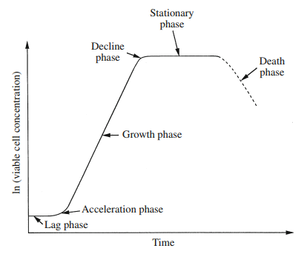

**Figure 1:** Batch cell growth described over the time lag, acceleration, growth, decline, stationary, and death phases of growth with the natural log of cell concentration for the y axis.

Cell growth rate during the growth phase can be calculated by the first order relation shown in Equation 1 if growth was only dependent on cell mass (Doran, 2013).

[1]

Where µ is the specific growth rate in [1/time] and x is the concentration [mass/volume] of cells. In a closed system where the culture is a homogeneous mixture, growth rate can be directly related to the rate of change of biomass, which is shown in Equation 2 (Doran). The combination of Equation 1 and 2 can be integrated using the initial concentration of cells at time zero equal to the initial biomass, x0, to obtain Equation 3 (Doran, 2013).

[2]

[3]

Equation 3 linearizes growth data to allow for visualization on a graph like the linear growth rate of cells shown in Figure 1. Equation 4 is simply a rearrangement of Equation 3 which gives exponential growth equation (Doran, 2013).

[4]

One important factor observed during this lab was the relative cell density. It was measured to determine growth kinetics of the bacteria. Since the relative density was observed rather than absolute density, the data only indicates a trend. The estimation is seen below in Equation 5 (Doran, 2013).

[5]

Another important measurement was the glucose concentration which was observed via use of the spectrophotometer. A glucose oxidase/peroxidase (GOPOD) kit was used which converted D-glucose into D-gluconate and hydrogen peroxide. The D-glucose concentration was determined through Equation 6 (Doran, 2013).

[6]

***Experimental***

In this work, three different samples of *Xanthomonas campestris* were used, each one having been inoculated for a different amount of time. The samples from cultures one and two were already prepared and inoculated for two days and one day respectively prior to the experiment. Standard microbiology laboratory instruments, such as micropipettes, flasks, incubators, etc., were used to perform the experiment. During the experiment, aseptic technique was used to prepare the third sample by aliquoting culture three into a 250 mL flask that contained media. Figure 2 includes the components of the media and the amounts that were used for this assay. Sample 3 was placed with the other two samples that were previously prepared in an incubated shaker at 25˚C and ~150 rpm.

Every 45 minutes, broth was pipetted from each of the three culture flasks and put in centrifuge tubes. For each culture, samples of fermentation broth were transferred to 1 mL microcentrifuge tubes, totalling two tubes for each sample. The aliquots of fermentation broth were placed in the microcentrifuge at 12,000 rpm for 25 minutes. The supernatant of each sample was transferred to a new tube to separate it from the concentrated cells. Since this laboratory experiment took two days to complete, the supernatant was placed in a freezer until the second day of the experiment. Using a spectrophotometer, the concentrated cells were analyzed to determine the relative cell density of the samples. The concentrated cells were diluted with water and measured in the spectrophotometer at 600 nm. This process was completed three more times in order to have four replicates of each culture sample, ranging from t = 0 to t = 135, and concluded the first day of the experiment.

The second day of the experiment was dedicated to measuring the glucose concentration and xanthan concentration of the fermentation samples. To prepare the samples to measure the glucose concentration, supernatant was diluted with DI water and aliquoted in a new tube with GOPOD. Each mixture of the diluted cells and GOPOD was incubated at 40˚C for 20 minutes before they were placed in the spectrophotometer. The absorbance of the samples was analyzed at 510 nm and used to calculate the glucose concentration, using Equation 8 previously stated above.

To calculate the xanthan concentration, a calibration curve was created to determine unknown concentrations of xanthan in the fermentation samples. A stock solution of 0.1 g/L of xanthan gum in water was provided, and it was added into a tube. A series of dilutions were completed using the stock solution and water, creating five tubes of different concentrations of xanthan gum. In a fume hood, concentrated sulfuric acid was added to each tube and mixed for 30 seconds. The temperature of the tubes increased as they were shaken, and the tubes were placed in ice until they were back to room temperature. These five samples and water used as the blank, were measured in the spectrophotometer at 325 nm. The data was then used to create a plot of xanthan concentration versus absorbance. For each sample and time, a 10x dilution of the supernatant with DI water was made. To make sure the absorbance values were within range of the calibration curve, the sample that had been incubated the longest, t = 2925, was tested first. The sample was prepared with the sulfuric acid in the same manner that the calibration curve dilutions were prepared. When analyzed in the spectrophotometer at 325 nm, the absorbance value was not within the range of zero to 0.8. A 200x dilution of the sample at t = 2925 was prepared and tested. This sample yielded an absorbance value of 0.507, which was within range of the calibration curve. A 200x dilution was performed on all of the remaining samples, and they were prepared with sulfuric acid in the same manner as the sample previously tested to check the absorbance range. The absorbance of the samples were read in the spectrophotometer at 325 nm and used for data analysis. Figure 2 visually represents the processes used in this laboratory experiment.

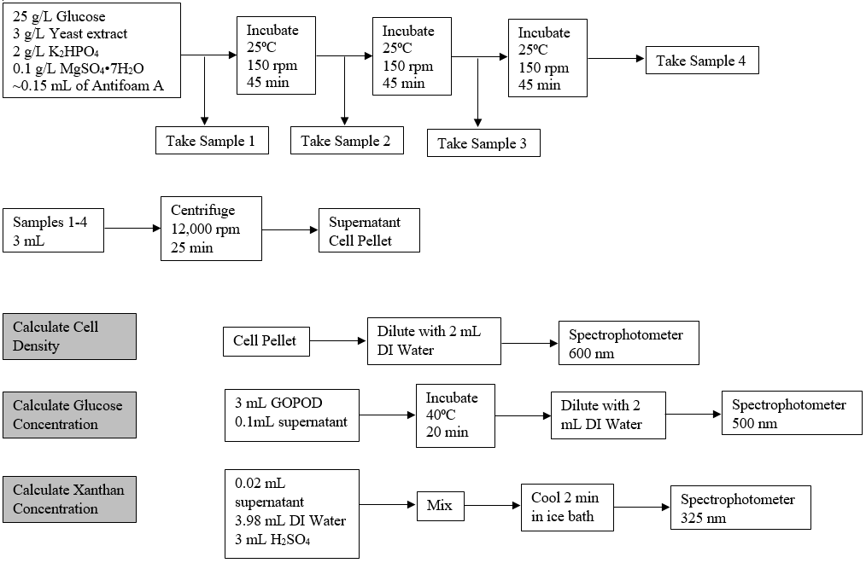

**Figure 2:** Flow diagram of the experimental steps and procedures that were completed in the experiment to analyze the fermentation process.

***Presentation and Discussion of Results***

In order to determine the concentration of xanthan in the experimental solutions, the absorbance values of the calibration solutions at 325 nm were plotted against the known concentrations of xanthan solutions (Figure 8, Appendix A). The linear regression function of this data was used to calculate the xanthan concentrations of the fermentation broths from the absorbance values (Appendix B, Sample Calculations 3). The relative cell density was calculated from the OD600 data using Equation 5, and the glucose concentration was calculated from the absorbance values at 510 nm using Equation 6 (Appendix B, Sample Calculations 1-2). Multiple sets of relative cell density, xanthan concentration, and glucose concentration data at two experimental temperatures, 25˚C and 30˚C, were combined. For both temperatures, the averages for relative cell density, xanthan concentration, glucose concentration, and standard deviation were calculated at each time point. The data was analyzed to find any points that were beyond two standard deviations from the average; these points were removed, and the averages and standard deviations were re-calculated. One data point was removed from the 25˚C data set (xanthan concentration at t = 1380 minutes), and four data points were removed from the 30˚C data set (xanthan concentration points at t = 90 minutes and t = 2970 minutes, relative cell density points at t = 1440 minutes and t = 2925 minutes).

The cleaned data sets were used to plot the relative cell density, glucose concentration, and xanthan concentration versus time for each temperature (Figures 3-4). When the cells were fermented at 30˚C, the final relative cell density and xanthan gum concentration was greater, and the final glucose concentration was smaller compared to the 25℃ fermentation. The greater response to the increase in temperature is further seen in Figure 5 where the relative cell density curves for both temperatures are graphed versus time.

The cell growth rate during the fermentation process was determined by plotting the natural log of the cell densities versus time (Figure 6). Equation 3 was used to calculate the cell growth rate, μ [minutes-1]. Only points within the growth phase, between t = 0 minutes and t = 1675 minutes were used in this graph as points outside of this range include the stationary phase, which would not accurately represent the growth rate of the cells in the fermentation processes. Despite the fermentation at 30˚C yielding both more cells and xanthan gum, calculating the growth rate of both fermentation situations shows that the 25˚C fermentation process has a growth rate of 0.0032 min-1 while the 30˚C fermentation process has a growth rate of 0.0026 min-1. The data suggests that fermentation at 25˚C produces cells 23% faster than the 30˚C fermentation, meaning that a fermentation temperature of 25˚C is more ideal for the growth of bacteria *Xanthomonas campestris*.

Both data sets showed significant deviation from the theoretical concentration curves and had large values of standard error for the concentration curves and cell growth curves. Varying spectrophotometer values for singular fermentation broth samples contributed to the large amount of error. In addition, there was potential causes of error in diluting the fermentation broth to ensure the absorbance values were within range of the calibration curve and human performance error.

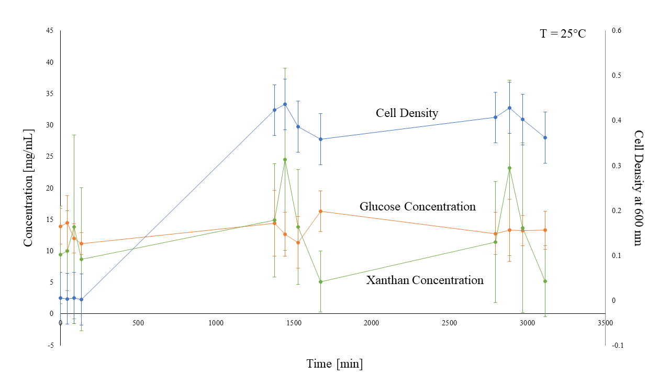

**Figure 3:** Relative cell density at 600 nm, glucose concentration, and xanthan concentration versus time [minutes] at a fermentation temperature of 25˚C. The general shape of the relative cell density curve matches what was expected in theory (shown in Figure 1). However, it was expected that the concentration of glucose would consistently decrease while the concentration of xanthan would consistently increase.



**Figure 4:** Relative cell density at 600 nm, glucose concentration, and xanthan concentration plotted against time (minutes) at a fermentation temperature of 30˚C. The general shape of the relative cell density curve matches what was expected in theory, and the xanthan and glucose concentration curves show the opposite of the expected decrease in glucose concentration over time and increase in xanthan over time.

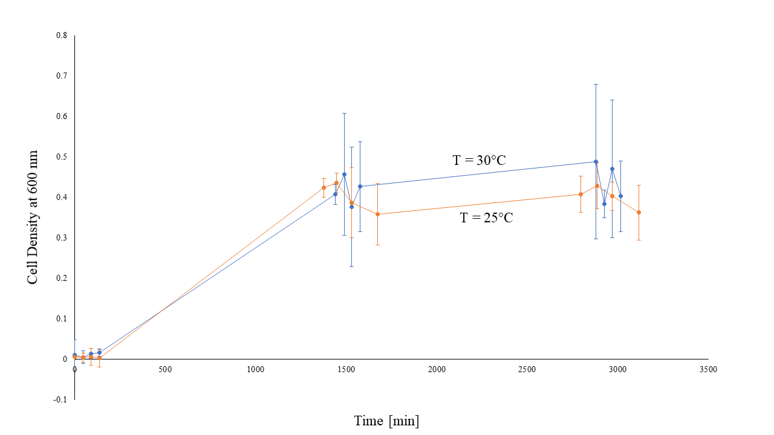

**Figure 5:** Relative cell density at 600 nm versus time [minutes] for fermentation temperatures of 25˚C and 30˚C. The data suggests that at a fermentation temperature of 25˚C, *Xanthomonas campestris* growth rate is quicker than at a fermentation temperature of 30℃.

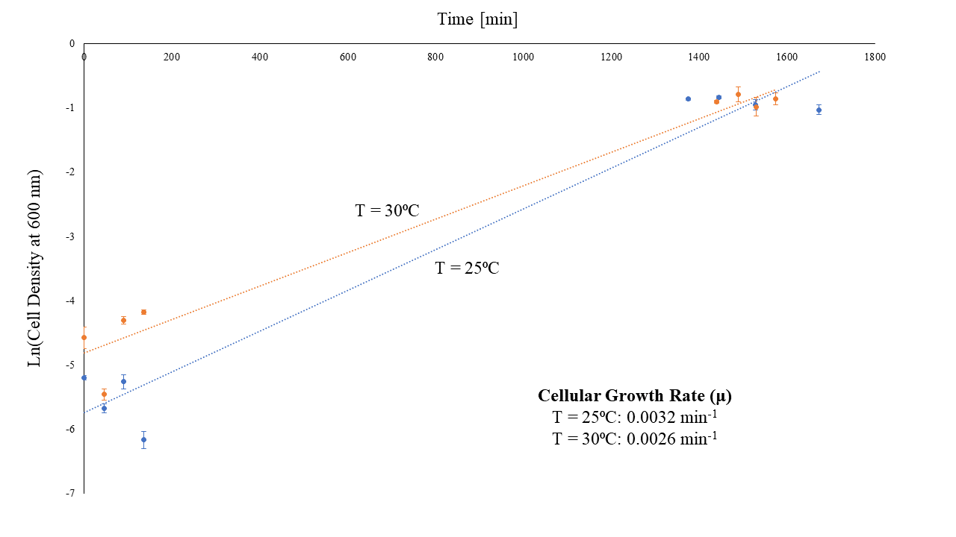

**Figure 6:** The natural log of the relative cell density values at 600 nm plotted over time. The slope of the linear regression lines give the cellular growth rate, μ, for each fermentation temperature (Equation 3). The slope of the 25˚C fermentation is 23% greater than that of the 30˚C fermentation, meaning that the 25˚C fermentation conditions are more ideal for *Xanthomonas campestris* growth.

In order to determine the success of the two fermentation situations, the theoretical yield of xanthan gum was calculated and compared to the observed yield. Equation 7 shows the stoichiometry of the reaction performed by *Xanthomonas campestris* to convert glucose to xanthan gum (Najafpour, 2007). It was known that the initial amount of glucose in the fermentation broth was 2.5 g. By using the stoichiometry of the reaction, the theoretical yield of xanthan is 1.9 g (Appendix B, Sample Calculations 4).

1 glucose + 0.23 O2 + 0.01 NH3 → 0.75 xanthan gum + 0.09 cells + 0.27 CO2 + 0.13 H2O [7]

The observed xanthan yield was calculated with two methods, the first of which was graphing xanthan gum concentration versus glucose concentration (Figure 7). A linear trendline was found and used to calculate the yield of xanthan gum with the average final glucose concentration for each fermentation temperature (Appendix B, Sample Calculations 5). For a fermentation temperature of 25˚C, a yield of 1.27 g of xanthan gum was calculated and for a fermentation temperature of 30˚C, a yield of 2.19 g of xanthan gum was calculated.

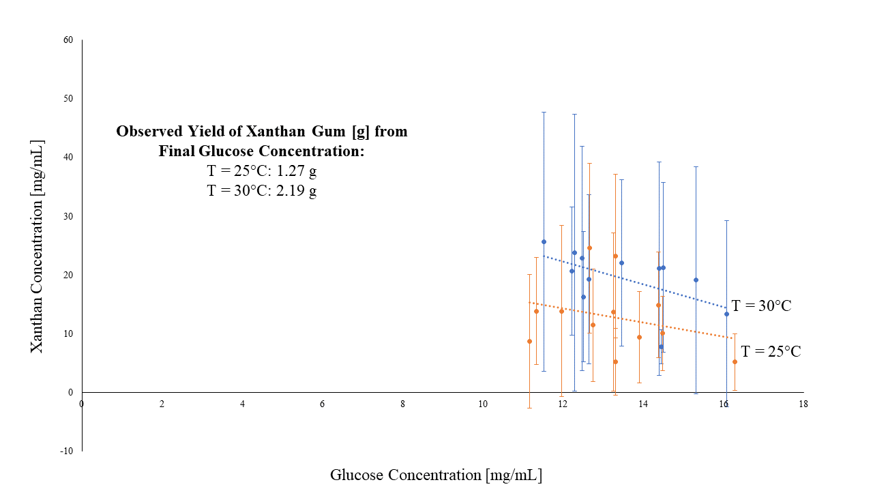

**Figure 7:** Plot of xanthan concentration against glucose concentration. The linear regression models for each fermentation temperature were used to calculate the final xanthan gum yield from the final glucose concentration. The 25˚C fermentation yielded 1.27 g of xanthan gum while the 30˚C fermentation yielded 2.19 g of xanthan gum.

The second method of calculating observed xanthan gum yield used the initial glucose concentration. It was calculated that the 25˚C fermentation yielded 20.7% of the theoretical xanthan gum yield, or 0.39 g of xanthan gum, while the 30˚C fermentation yielded 82.5% of the theoretical yield, or 1.57 g of xanthan gum (Appendix B, Sample Calculations 6).

Both methods of calculating the observed yield of xanthan gum showed that the 25˚C fermentation yielded less xanthan gum than the 30˚C fermentation. The graphical method calculated a greater yield of xanthan gum for both fermentation cases than the calculation using the initial glucose concentration. Additionally, the graphical method calculated a xanthan gum yield of 2.19 g, which is theoretically impossible. The difference in values calculated by the two methods is due to the fact that the graphical method uses the trend of data while the second method uses only a singular data point. The graphical method has greater variation due to the wide range of error in each data point, as can be seen with the size of the error bars in Figure 7.

***Conclusions and Recommendations***

By sampling multiple *Xanthomonas campestris* cultures undergoing fermentation at 25˚C and 30˚C over two days, data for relative cell density, glucose concentration, and xanthan concentration was collected. Analysis showed that the 25˚C and 30˚C fermentations had growth rates of 0.0032 min-1 and 0.0026 min-1, respectively. However, when comparing the final relative cell densities of the two fermentation broths, the 30˚C fermentation had a greater relative cell density. The final relative cell density results conflict with the cell growth rate results. This is due to having a large observed error in the data sets. Theoretically, the fermentation with the greater cell growth rate should have the greater final cell density.

Neither fermentation broth showed the expected trend of a continuously decreasing glucose concentration with an inversely increasing xanthan concentration. Sources of error may include varying spectrophotometer absorbance values, problems with diluting the fermentation broth to ensure that the absorbance values were within range of the calibration curve, and human error in procedural performance. The observed trends were used to calculate the xanthan gum yield, knowing that the theoretical yield was 1.9 g of xanthan gum. In calculating the yield graphically, the 25°C fermentation produced 1.27 g of xanthan gum, a 66.8% yield, and the 30°C fermentation produced 2.19 g of xanthan gum, a 115.3% yield, which is impossible. When the yield was calculated using the known initial glucose concentration and the final xanthan concentration, it was found that the 25°C fermentation produced 0.39 g of xanthan gum while the 30°C fermentation produced 1.57 g of xanthan gum, a 20.7% yield and an 82.5% yield, respectively. The difference in these results is due to the graphical method using a data trend based upon glucose concentration and xanthan concentration data that both had large observed error. The method using the known initial glucose concentration was only based on the final xanthan concentration data. Despite the data variance, both methods confirm that the 30°C fermentation produces a larger mass of xanthan gum than the 25°C fermentation. From these results, it is recommended that the fermentation process for xanthan gum production be performed at 30°C rather than 25°C in order to have larger yields per unit time, which is more cost-effective for industrial purposes.

***Nomenclature***

A area [m2]

D-glucose D-glucose concentration [mg/mL]

m mass [kg]

μ specific growth rate [minutes-1]

ODblank optical density of blank [-]

ODsample optical density of sample [-]

OD600 optical density at 600 nm [-]

⍴ density [mg/mL]

⍴cell relative cell density [mg/mL]

rx volumetric rate [kg m-3 min-1]

t time [minutes]

T0 initial temperature [K]

Tf final temperature [K]

ΔT temperature change [-]

V volume [mL]

x concentration [mg/mL]

x0 initial concentration [mg/mL]

***Literature Cited***

Doran, P. M. (2013). Bioprocess Engineering Principles. Elsevier Science & Technology Books, pg 599 - 703

Najafpour, G. (2007). Material and Elemental Balance. *Biochemical Engineering and Biotechnology*, 228–251.

Shu, C., & Yang, S. (1989). Effects of temperature on cell growth and xanthan production in batch cultures of Xanthomonas campestris. *Biotechnology and Bioengineering,35*(5), 454-468.

***Appendices***

**Appendix A: Figures and Tables**

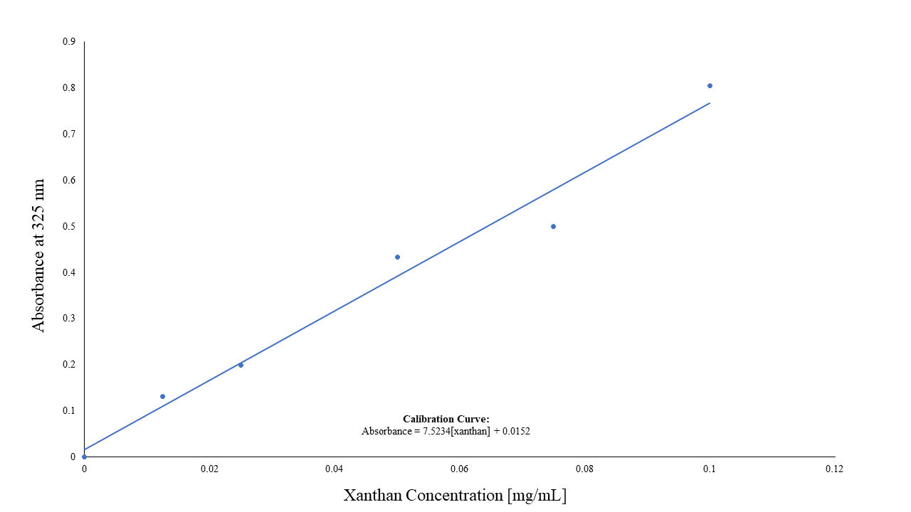

**Figure 8:** The xanthan gum concentration calibration curve. The linear regression listed in the figure was used to calculate the concentration of xanthan gum within the fermentation broth samples after finding the absorbance with a spectrophotometer at 325 nm.

**Appendix B: Sample Calculations**

